# **Your Application**

This is the team application form of the Project Abstract Submission phase to the Dell Technologies Graduation Project Competition for Turkey, Middle East and Africa.

Teams participating should consist of 3-6 team members with an assigned team leader to submit the entries and lead the communication throughout the competition timeframe with Dell Technologies. Teams should also have an assigned faculty advisor.

* **Part 1 - Team**
* **Team Leader Name\***
  + **First Nour**
  + **Last Bahaa**
* **Team Leader Email\***
  + **nour1702084@miuegypt.edu.eg**
* **2nd Team Member Name\***
  + **First Abanoub**
  + **Last George**
* **2nd Team Member Email\*** 
  + **Abanoub1703340@miuegypt.edu.eg**
* **3rd Team Member Name\***
  + **First Ibrahim**
  + **Last Fawzy**
* **3rd Team Member Email\***
  + [**ibrahim1707047@miuegypt.edu.eg**](mailto:ibrahim1707047@miuegypt.edu.eg)
* **4th Team Member Name**
  + **First Mai**
  + **Last Mahmoud**
* **4th Team Member Email**
  + **mai1707685@miuegypt.edu.eg**
* **Faculty Advisor Name\***
  + **First Khaled**
  + **Last Hussein**
* **Faculty Advisor Email\***
  + **khaled.hussein@miuegypt.edu.eg**
* **Faculty Advisor University Job Title\***
  + **Professor**
* **How many male team members?\***
  + **2**  
    .
* **How many female team members?\***
  + **2**
* **Your University\***
  + None of the above
* **Your University (in case you didn't find it above)**
  + **Misr International University (MIU)**
* **Country of Residence\***
  + Egypt

**Part 2 - Project**

**Project Title\***

* + **Wheat Impurities' Detection**

**Which sector does your project tackle?\***

* + **Well-Being,**
  + **Healthcare,**

**Which Technology area are you using to tackle the addressed problem?\***

* + **Internet of Things (IoT),**
  + **Multi-Cloud,**
  + **Artificial Intelligence (AI).**

**What is the main problem that you are solving?\***

* + **Our project's main problem is that: Wheat grows in more land than any other crop and most traded product all over the world. On the other hand, it has been threatened by two main problems which are Wild Oat and Rust disease. Differentiating between Wild Oats and wheat in the early stages of the Wild Oats growth is extremely hard. That’s because, they are quite similar in shape and color;moreover, if the farmer didn’t remove it from the land as soon as it appears it will spread its seeds in the ground, which will stay in the land for many years according to the land conditions.**
  + **For the rust, there’re the three different kinds in Egypt. Rust appears due to the change in the weather.**

**What is the importance of this problem?\***

* + **Wild Oat plant and Wheat Rust disease the crop with its expansion, it reduces the wheat production by 93% for every square-meter. Thus, if the farmer didn't detect the wild oats within the first 30 days of growing within the wheat, it will kill the crop and spread about 100 to 150 of the Oats seeds. Hence, detection in the early stages is a must. Pervasion in wheat fields can diminish yield by as much as 80%. For example in Egypt, they plant almost 9 million tons of Wheat; however, they use almost 14 million tons. Due to that they export the rest by 23 billion pounds yearly to fulfill the gap needs.**

**What are the current solutions?\***

* + **1 - Using expensive Chemicals, which decreases the nutritional value of the wheat.**
  + **2 - Using Winter Planting,which farmers use to plant clovers to clean their land from the appearance of Wild Oats that they need to wait until clovers to be harvard ,will delay the Wheat season.**
  + **3 - Using Lie Agriculture irrigation,which farmers put water all over their land as when Wild Oats grow faster than the wheat so it appears,will delay the season of the Wheat.**

**How will your solution solve the problem? What is new?\***

* + **To our knowledge, such a problem wasn’t yet solved and no one did try to solve it the way we are planning to do.**
  + **We are going to make real-time detection to decrease the appearance and the harm of the Wild Oat and Wheat Rust to increase the Wheat crop production.**
  + **So, We will use data acquisition(We are going to construct our own dataset), image processing(We are going to apply it on images and videos for preprocessing) and deep learning techniques(We are going to apply it for classification of the impurities).**

**What is the expected impact of your solution from various perspectives (social, commercial, environmental, etc)?\***

* + **It will decrease the number of Wild Oats and rust in the Wheat and increase the crop production. Producing it by the best quality and in larger crop weight output. Above all, it will increase the farmer income and reduce the work and the time he takes in the field to recognize the Wild Oats. Besides, the money he pays for using the expensive high-quality chemicals to control Wild Oats.**

**Give a high level functional description of your solution. How will it be used?\***

* + **The system proposed in this document is divided into 3 fully connected systems. At first, the system consists of a camera, which will be able to clarify Wild Oats and Wheat with it’s different species within the field and also classify where the healthy wheat is. Then comes the Website system, which is connected to our first system to receive the results from the detection. It contains a dashboard to view how many wild oats and wheat rust within the field also, the user will be able to contact the admin using the mailing system. Finally, the Wind monitoring system, which is the main function to predict if the incoming wind has fungicides that will cause rust in our wheat and sends it’s result to our second system.**
  + **The User is going to use the camera which we implemented and move in the field. Then the camera will begin recording the videos and send them to the cloud. Our model on the cloud will start to break first the video into some frames and apply image processing on these frames & data preprocessing. When our images are ready they will be tested on our model to classify the healthy wheat, wild oats and the wheat rust. Then it’s going to send these classification results to our database so when the user tries to use the system he will see these results in a form of charts and he can print his own report. Also our system offers a wind monitoring system to monitor if the incoming wind has fungicides or not so it can predict when the rust will happen in the wheat field.**

**Give a high level technical description of your solution: architecture, technology, integration, innovative components, etc.\***

* **First thing, the machine will collect all the knowledge from the input images(size, date and types), where these input images have different specifications. Then some pre-processing will occur by our system to normalize these images so all the pictures are visiting have the same size and dimensions and have full RGB channels. This phase goes to assist us within the main processing phase once we must use these input images. The most processing stage is where we've our data in a very normalized sequence, so we are able to now begin to run the training phase of our model to start feeding the algorithm with the pictures. Then comes our testing phase(Validation phase), where our model is prepared to be evaluated and tested by the pictures. We used a layer or shape of Neural Networks which is the Mask R-CNN deep learning approach to simply & faster detection of the wild oat grass & the rusty wheat from the healthy wheat plants within the sector.** 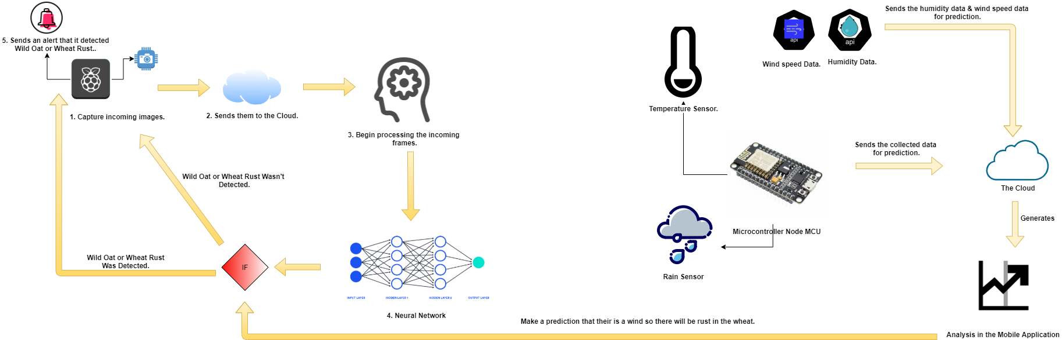
* **After our model is finally ready and tested it'll be embedded during a Raspberry Pi which is connected to a camera module which may be detecting the wild oat grass using real-time camera recording ,so it'll keep recording and send them to the Cloud. Therefore, our model can divide these videos into frames and provide them with labels, organize them and resize them to the suitable size for feature extraction.**
* **If our model detected a wild oat grass grass or a rust within the wheat among the wheat field, it will make the buzzer attached to the Raspberry Pi to make an alert noise to illustrate that a wild oat grass grass or rust within the wheat has been detected within this area.**
* **Our second device consists of a Node MCU microcontroller, which some sensors are connected to. These sensors are Rain drop sensor and Temperature sensor. Also, the Humidity data and also the Wind speed data we are visiting get these data by using the Weather API.**
* **After our weather monitoring system is completely built it's visiting to detect a high-speed wind which has fungicides by collecting the data from the sensors and comparing it to daily data. Then, it predicts if there's visiting wind, which is in a position to cause rust. Also, these data are sent to our mobile application which incorporates a dashboard to make analysis about these wind data.**

**Give a high level description of your solution development environment, platform, tools, etc.\***

* + **Anaconda Python Environment: Used for creating an environment to build our classification model.**
  + **Camera Module for Raspberry Pi: Used for real-time detection of the wild oats and wheat rusts.**
  + **Raspberry Pi 3: Used to connect our camera with the cloud provider.**
  + **Temperature Sensor: Used to measure the temperature in the area frequently.**
  + **Rain Drop Sensor: Used to measure the Rain drops in the area frequently.**
  + **Humidity API: Used to get the data of the humidity of the area frequently.**
  + **Wind Speed API: Used to get the data of the wind sped & direction of the area frequently.**
  + **Arduino UNO: Used for carrying all the sensors and sending the data to the cloud.**
  + **Google Cloud: Used for carrying our model for the classification process.**
  + **Database: Used to carry all the user’s data and history of classification.**
  + **Laravel version 8: Web application that is going to represent our system.**

**How will you manage your product development cycle, your quality assurance process, your solution deployment logistics, etc?\***

* + **In the development cycle, we are going to collect a real dataset of the wild oat which isn’t found online in cooperation with the Agriculture Research Center and the farmers. After image acquisition, we are going to apply the data preparation methods to clean the data, then construct our model using machine learning and deep learning approaches on the acquired images. After training our model and that it’s fed enough to be evaluated, our application functionality with the help of experts will be ready for taking real-time images of the wheat fields and classifying the wheat impurities' from the healthy wheat.**
  + **After finishing the model and deploying it doesn’t mean that our work is done, we will take user’s feedback of the classification process and try more machine learning/ deep learning methods and redeploy again to get the best results.**

**Give the most relevant plans that you have developed for your project (for example, time schedule, resource plan, training plan, risk management, contingency plan, etc.)\***

* + **Contingency plan.**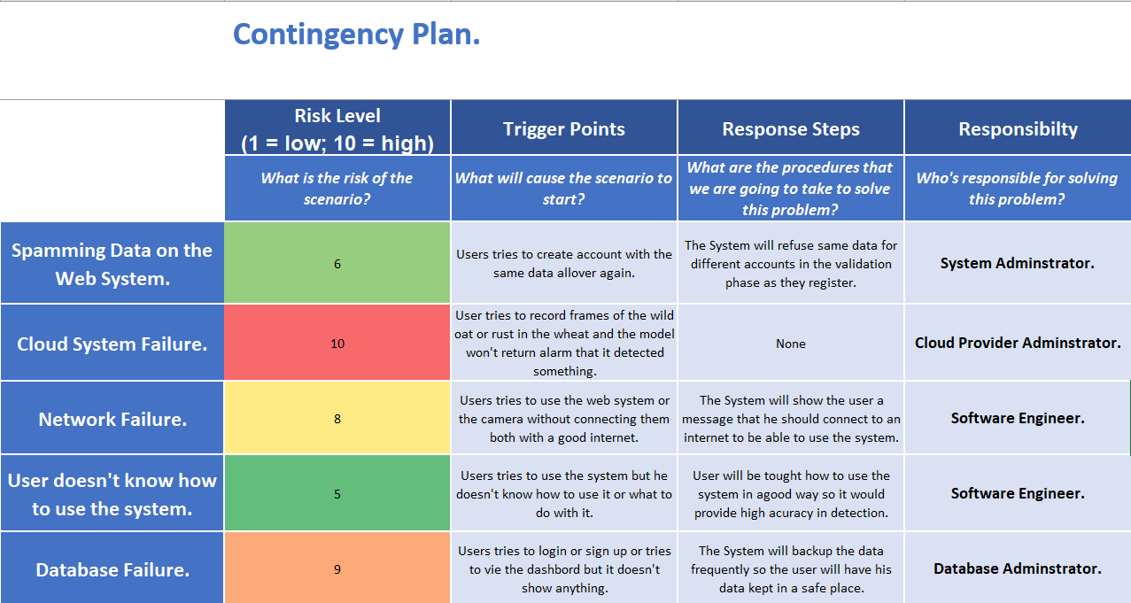

**GANTT Chart.**

